Shifting dynamics: Changes in the relationship between total fertility rate and contraceptive prevalence rate in Jordan between 2012 and 2017

Kristin Bietsch, Ali Arbaji, Jennifer Mason, Rebecca Rosenberg, and Malak Al Ouri

# September 2020

# Appendices

## Appendix 1: Analysis of contraceptive calendar data

Presented below in Figure A.1 are monthly estimates with confidence intervals, as well as CPR and mCPR for married women, aged 15-44 at the time of the 2012 and 2017 JPFHS. Measurements are different from the other estimates of CPR discussed in this paper, the numbers in Figure 1 exclude women aged 45-49.

*Figure A.1*

Previous research by Bradley, Winfrey, and Croft analyzes contraceptive calendars in a similar manner[1] and considers a calendar to be inaccurate if the difference between the current use measure from the previous survey and the monthly measure from the calendar for the same time period is statistically significant. We can see in the figure that the calendar data shows much lower CPR and mCPR at the end of 2012 compared to the 2012 JPFHS. Additionally, we know that contraceptive use declined overtime, based on the current status measure in both surveys, but the calendar shows an increase over time.

Further research into the contraceptive calendar reveals additional problems. We examined duration of injectable use in the calendar, knowing that all injectables available in Jordan are effective for three months. While injectables cannot be stopped before the end of the three month-period, Figure A.2 shows that injectables were discontinued at unpredicted periods of use, which include durations that are not multiples of three.

### Internal Validation of Contraceptive Prevalence Rates in the JPFHS

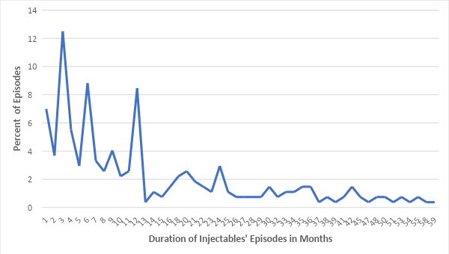

*Figure A.2*

Finally, the calendar data was checked for next month events of women who discontinued using a method as they wanted to become pregnant. Table A.1 shows that 53% of women who stopped a method to become pregnant reported being pregnant during the next month. This figure is appears to be inflated, considering that the monthly probability of conceiving is near 20%[2] and is expected to be lower with previous use of hormonal contraceptives. These results suggest inaccuracies in the contraceptive calendar in 2017. However, they cannot provide evidence of inaccuracies specifically in the measure of current contraceptive use (CPR).

*Table A.1*

|  |  |  |  |  |
| --- | --- | --- | --- | --- |
| **Percent Distribution of Next Month Event for Women Who Discontinued Because of Desire for Pregnancy, 2017 JPFHS** | | | | |
| **Method** | **Next Month Event** | | | |
| **Not Using %** | **Other %** | **Pregnancy %** | **Total #** |
| Pill | 45.7 | 1.6 | 52.7 | 957 |
| IUD | 46.7 | 1.8 | 51.5 | 1,084 |
| Injections | 61.9 | 1.1 | 37.0 | 54 |
| Condom | 46.5 | 0.5 | 53.0 | 371 |
| Periodic Abstinence | 52.2 | 3.7 | 44.2 | 60 |
| Withdrawal | 41.2 | 2.1 | 56.7 | 1,163 |
| Other | 100.0 | 0.0 | 0.0 | 1 |
| Norplant | 75.7 | 0.0 | 24.3 | 25 |
| LAM | 43.7 | 1.6 | 54.7 | 60 |
| Female condom | 85.9 | 0.0 | 14.1 | 5 |
| **Total** | **45.2** | **1.7** | **53.0** | **3,780** |

**Appendix 2: Algorithm for calculating Unmet Need**[3]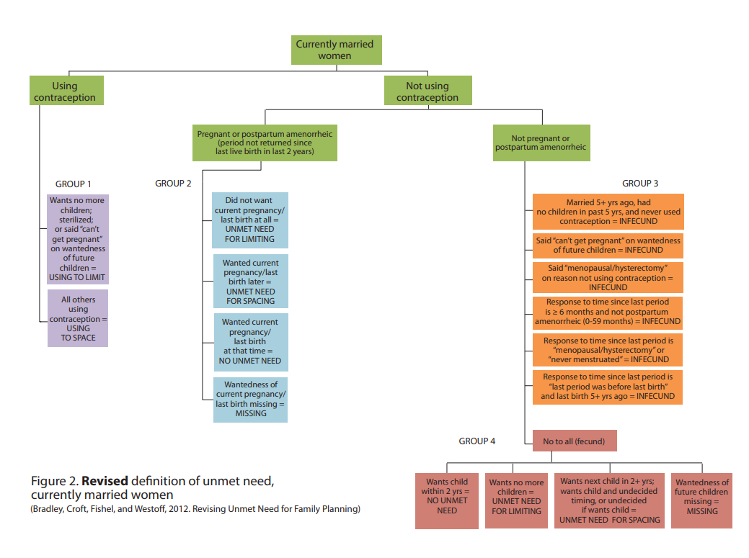

## Appendix 3: Proximate Determinants of Fertility Data

### 2012 Proximate Determinants of Fertility Data, JPFHS

|  |  |  |  |  |  |  |  |
| --- | --- | --- | --- | --- | --- | --- | --- |
| Age | Proportion of married | ASFR Per 1000 | ASFR |  | Marital ASFR | | Remark |
| 15-19 | 6 | 26 | 0.026 |  | 0.433 | 0.325 | Adjusted for 15-19 |
| 20-24 | 32.6 | 139 | 0.139 |  | 0.426 | 0.426 |  |
| 25-29 | 67.3 | 209 | 0.209 |  | 0.311 | 0.311 |  |
| 30-34 | 79.6 | 180 | 0.180 |  | 0.226 | 0.226 |  |
| 35-39 | 82.8 | 111 | 0.111 |  | 0.134 | 0.134 |  |
| 40-44 | 84.7 | 34 | 0.034 |  | 0.040 | 0.040 |  |
| 45-49 | 83.1 | 3 | 0.003 |  | 0.004 | 0.004 |  |
|  | 54.3 | TFR= | 3.5 |  | TMFR= | 7.3294 |  |
| Cm=Index of marriage=CM=TFR/TF |  |  |  |  |  |  | 0.47890 |

|  |  |  |  |  |  |
| --- | --- | --- | --- | --- | --- |
|  |  |  |  |  |  |
| Current contraceptive method | Frequency | Proportion using at survey | Method Mix | Use effectiveness | Use * Effectiveness |
| Not using | 4,172.23 |  |  |  |  |
| Pill | 872.36 | 0.081 | 0.1327 | 0.92 | 0.0747 |
| IUD | 2,288.81 | 0.213 | 0.3482 | 0.96 | 0.2045 |
| Injections | 100.340263 | 0.009 | 0.0153 | 1 | 0.0093 |
| Condom | 847.420394 | 0.079 | 0.1289 | 0.81 | 0.0639 |
| Female sterilization | 237.891215 | 0.022 | 0.0362 | 1 | 0.0221 |
| Male sterilization |  | 0.000 | 0.0000 | 1 | 0.0000 |
| Periodic abstinence | 379.84 | 0.035 | 0.0578 | 0.50 | 0.0177 |
| Withdrawal | 1,540.48 | 0.143 | 0.2343 | 0.50 | 0.0717 |
| Other | 271.6031345 | 0.025 | 0.0413 | 0.5 | 0.0126 |
| Implants/Norplant | 35.0231322 | 0.003 | 0.0053 | 1.00 | 0.0033 |
| Total | 10745.99993 | 0.61 | 1.0000 |  | 0.4798 |
|  |  | 0.61 |  |  | 0.7842 |
|  |  |  |  |  |  |
|  |  | Index of Cc | 1- (1.08 * Prevalence * effectiveness) |  | 0.48186372 |
|  | Source Use effectiveness: Stover et al., 1997 and Stover et al., 2000. | | |  |  |

|  |  |
| --- | --- |
|  | PPI |
| Postpartum insusceptibility | 3.1 |
| Ci = index of post partum insusceptibility | 0.925925926 |
| Ci = 20 / (18.5 + PPI) |  |

### 2017 Proximate Determinants of Fertility Data, JPFHS

|  |  |  |  |  |  |  |  |
| --- | --- | --- | --- | --- | --- | --- | --- |
| Age | Proportion of married | ASFR Per 1000 | ASFR |  | Marital ASFR | | Remark |
| 15-19 | 7.6 | 27 | 0.027 |  | 0.355 | 0.266 | Adjusted for 15-19 |
| 20-24 | 33.3 | 109 | 0.109 |  | 0.327 | 0.327 |  |
| 25-29 | 63.8 | 156 | 0.156 |  | 0.245 | 0.245 |  |
| 30-34 | 78.4 | 137 | 0.137 |  | 0.175 | 0.175 |  |
| 35-39 | 81.7 | 88 | 0.088 |  | 0.108 | 0.108 |  |
| 40-44 | 83.2 | 27 | 0.027 |  | 0.032 | 0.032 |  |
| 45-49 | 81.6 | 2 | 0.002 |  | 0.002 | 0.002 |  |
|  | 55.8 | TFR= | 2.7 |  | TMFR= | 5.7782 |  |
| Cm=Index of marriage=CM=TFR/TF |  |  |  |  |  |  | 0.47246 |

|  |  |  |  |  |  |
| --- | --- | --- | --- | --- | --- |
|  |  |  |  |  |  |
| Current contraceptive method | Frequency | Proportion using at survey | Method Mix | Use effectiveness | Use * Effectiveness |
| Not using | 6,616.07 |  |  |  |  |
| Pill | 1,077.46 | 0.078 | 0.1514 | 0.92 | 0.0722 |
| IUD | 2,858.56 | 0.208 | 0.4016 | 0.96 | 0.1998 |
| Injections | 105.060414 | 0.008 | 0.0148 | 1 | 0.0076 |
| Condom | 706.3044548 | 0.051 | 0.0992 | 0.81 | 0.0417 |
| Female sterilization | 208.308014 | 0.015 | 0.0293 | 1 | 0.0152 |
| Male sterilization | 0.500895158 | 0.000 | 0.0001 | 1 | 0.0000 |
| Periodic abstinence | 183.686817 | 0.013 | 0.0258 | 0.50 | 0.0067 |
| Withdrawal | 1,791.29 | 0.130 | 0.2517 | 0.50 | 0.0652 |
| Other | 148.471304 | 0.011 | 0.0209 | 0.5 | 0.0054 |
| Implants/Norplant | 38.2859432 | 0.003 | 0.0054 | 1.00 | 0.0028 |
| Total | 13734.00004 | 0.52 | 1.0000 |  | 0.4166 |
|  |  | 0.52 |  |  | 0.8038 |
|  |  |  |  |  |  |
|  |  | Index of Cc | 1- (1.08 * Prevalence * effectiveness) |  | 0.550081082 |
|  | Source Use effectiveness: Stover et al., 1997 and Stover et al., 2000. | | |  |  |

|  |  |
| --- | --- |
|  | PPI |
| Postpartum insusceptibility | 3.1 |
| Ci = index of post partum insusceptibility | 0.925925926 |
| Ci = 20 / (18.5 + PPI) |  |

1. Bradley, S.E.K., W. Winfrey & Croft, T.N. 2015. *Contraceptive use and perinatal mortality in the DHS: an assessment of the quality and consistency of calendars and histories.* DHS Methodological Reports No. 17. Rockville, Maryland, USA: ICF International. <https://dhsprogram.com/pubs/pdf/MR17/MR17.pdf>.
2. Evers, J.L.H. “Female subfertility.” *Seminar* 360 (9327): 151-159. https://doi.org/10.1016/S0140-6736(02)09417-5.<https://www.thelancet.com/journals/lancet/article/PIIS0140-6736(02)09417-5/fulltext>
3. Bradley, S.E.K., T.N. Croft, J.D. Fishel, & C.F. Westoff. 2012. Revising unmet need for family planning. DHS Analytical Studies No. 25. Calverton, Maryland, USA: ICF International. <https://dhsprogram.com/pubs/pdf/AS25/AS25%5B12June2012%5D.pdf>.